Resource Selection Timeout Settings
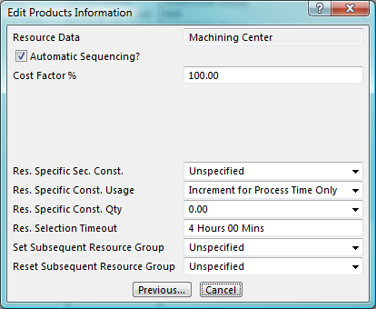
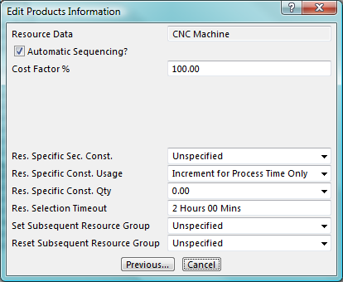
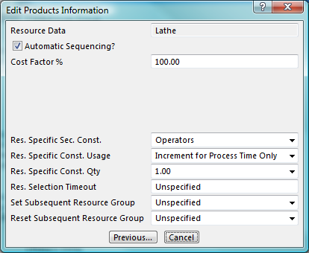
The 3 resources in the Turning Machines Group have the Resource Selection Timeout set as shown above.
The Machining Center is set to 4 Hours, The CNC Machine is set to 2 Hours and the Lathe has a default setting of ‘Unspecified’
This means that if an operation can be put on to the Machining Center within 4 Hours, it will be the first choice of the available resources. If it cannot be put on to the Machining Center within that time period, an attempt will be made to place the operation on to the CNC Machine provided it can go on within a period of 2 hours.
If neither of those choices are available then the operation will be placed on the first available resource in the Resources table (in this case the Lathe)
In the screen shot (below) The first operation of order (A001) uses the Machining Center for 2 hours and 50 minutes, the first operation of the second order (A002) uses the CNC machine for 1 hour 45 minutes.

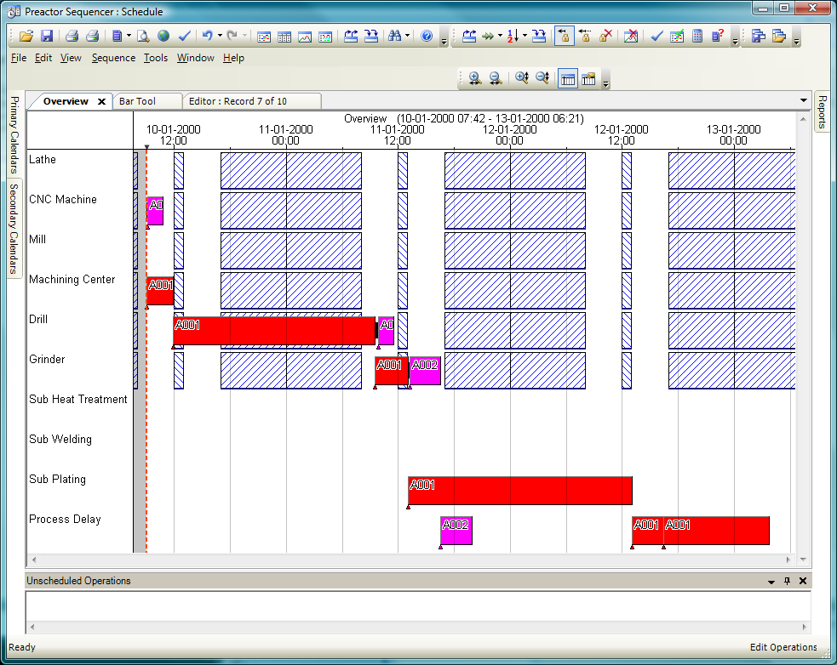
This means that the firsts operation of the next order (A003) CAN be placed on to the preferred resource (Machining Center) within the 4 hour period. The first operation of the next order (A004) CANNOT be placed on the Machining Center within 4 hours but CAN be placed on the CNC Machine. The first operation of the last order (A005) CANNOT be placed on either of the 2 preferred resources and is therefore placed on the first available resource in the Resource Table – the Lathe.

